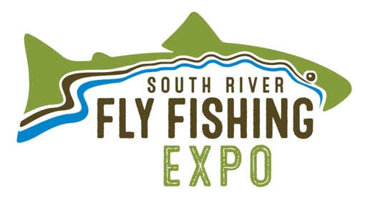
April 27 and 28, 2019
Destination Downtown Waynesboro is pleased to announce the dates of the 4th Annual South River Fly Fishing Expo. Thanks to our sponsors over the past three years we are growing and bringing more low impact tourism to Waynesboro. Your support of the South River Fly Fishing Expo has allowed Destination Downtown Waynesboro to fund:
- Stocking of 1000 Fingerling Brown Trout in the South River Downtown (2016)
- Purchase and install a custom Rainbow Trout Bike Rack at the Arch Ave. Parking Lot (2017)
- Make a $2000.00 Donation to Shenandoah Valley Trout Unlimited for Streambank Restoration (2018)
Our 2019 event will feature a great cast of local, regional, and nationally known fly-fishing professionals. There will be many great presentations on fly-fishing tactics, regional fisheries and some of the best fly tiers in the region will be demonstrating their skills. Our kids’ trout pond will provide a place for young anglers to learn to properly catch and release their trout into the South River. This year we will also be expanding our Ladies Intro to Fly Fishing Class to help bring more women to the sport of fly-fishing.
Destination Downtown Waynesboro needs your support to make the South River Fly Fishing Expo the fly-fishing destination event of the year. Your sponsorship of the South River Fly Fishing Expo is greatly appreciated.
Event Sponsor
Will be listed on The South River Fly Fishing Expo website with link a to your business website and advertising in the event program
- Platinum - $1000 – Full page business ad in event program
- Gold - $750 – 1/2-page business ad in event program
- Silver - $500 – 1/4-page business ad in event program
- Bronze - $250 – 1/6-page business ad in event program
Individual Sponsor
Line listing on The South River Fly Fishing Expo website and in event program
- Gold - $300
- Silver - $200
- Bronze - $100
Contact:
Tommy Lawhorne – Chairman, South River Fly Fishing Expo Committee
tommy@southriverflyshop.com – 540-649-1915
South River Fly Fishing Expo Sponsor Agreement

Event Sponsorship:
Name: ________________________________________________________________________
Address: _____________________________City: _______________State: ____ Zip: _________
Phone: _________________________Email: _________________________________________
Signed: ______________________________ Title: ____________________ Date: ___________

Platinum Sponsor - $1000 _____ Gold Sponsor - $750 _____
Silver Sponsor - $500 _____ Bronze Sponsor - $250 _____
All Fly-fishing Industry Sponsors will also receive booth space at the event to display goods and services. Platinum Sponsors will have first choice of up to 3 booth spaces at the entrances, Gold Sponsors - 3 booth spaces, Silver Sponsors – 2 Booth Spaces, and Bronze Sponsors – 1 Booth Space
Local Individual Sponsorship:
Name: ________________________________________________________________________
Address: ______________________________City: ________________State: ____Zip: ________
Phone: _________________________Email: _________________________________________
Signed: ______________________________ Title: _____________________ Date: __________

Gold - $300 _____ Silver - $200 _____ Bronze - $100 _____

Please make checks payable to:
Destination Downtown Waynesboro
301 West Main Street
Waynesboro, VA 22980

